# Phase 3 Documentation

|  |  |
| --- | --- |
| **Date** | **26-10-2023** |
| **Team ID** | **4126** |
| **Project Name** | **Personal Blog On IBM Cloud Static Web App** |

**Table of Contents**

|  |  |
| --- | --- |
| 1 | Introduction |
| 2 | Problem Statement |
| 3 | Website creation |
| 4 | Examples |
| 5 | Conclusion |

**Personal Blog On IBM Cloud Static Web App**

**INTRODUCTION:**

The task at hand is to create a personal blog, which has never been easier. Whether you want to share your thoughts, experiences, or expertise with the world, having an online platform is essential. However, not all hosting solutions are created equal, and this is where IBM Cloud's Static Web App service comes into play.

**PROBLEM STATEMENT:**

Create a personal travel blog hosted on IBM Cloud Static Web Apps. Share your travel adventures, tips, and captivating photos with the world. Use IBM Cloud Static Web Apps to easily update your blog and document your journeys. Inspire others to explore the beauty of the world and forge unforgettable memories!

**WEBSITE CREATION:**

Creating a static web app on IBM Cloud involves hosting a website with fixed content, suitable for blogs or informational pages. It uses IBM Cloud's services to store and deliver web files, ensuring scalability and security. Users design the site locally, then deploy it to IBM Cloud via tools like CLI or GitHub Actions. The app relies on HTML, CSS, and JavaScript, lacking server-side processing. Benefits include fast loading times, cost efficiency, and simplicity, making it ideal for personal blogs. IBM Cloud provides a reliable and flexible platform for hosting static web apps with minimal maintenance.

**EXAMPLES:**

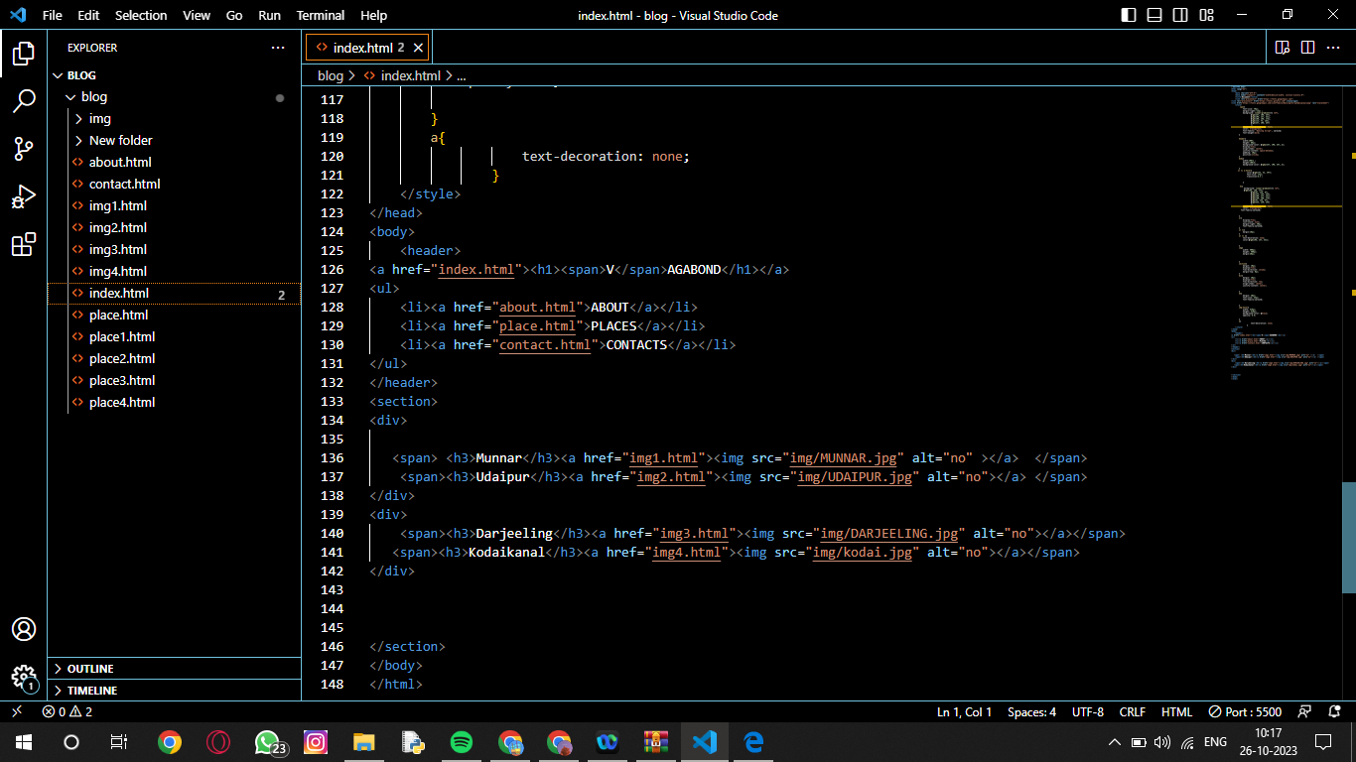

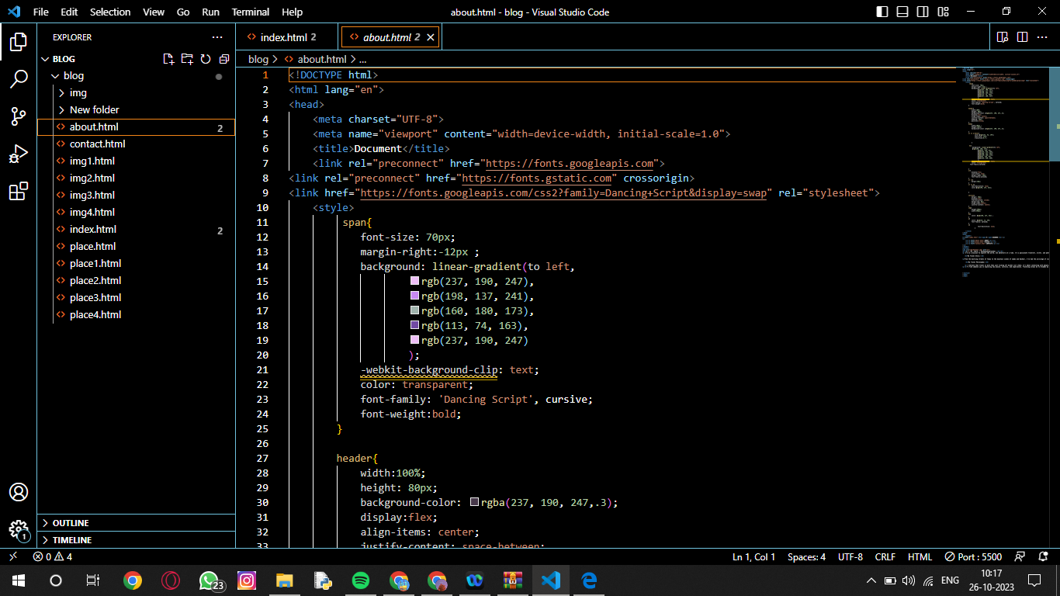

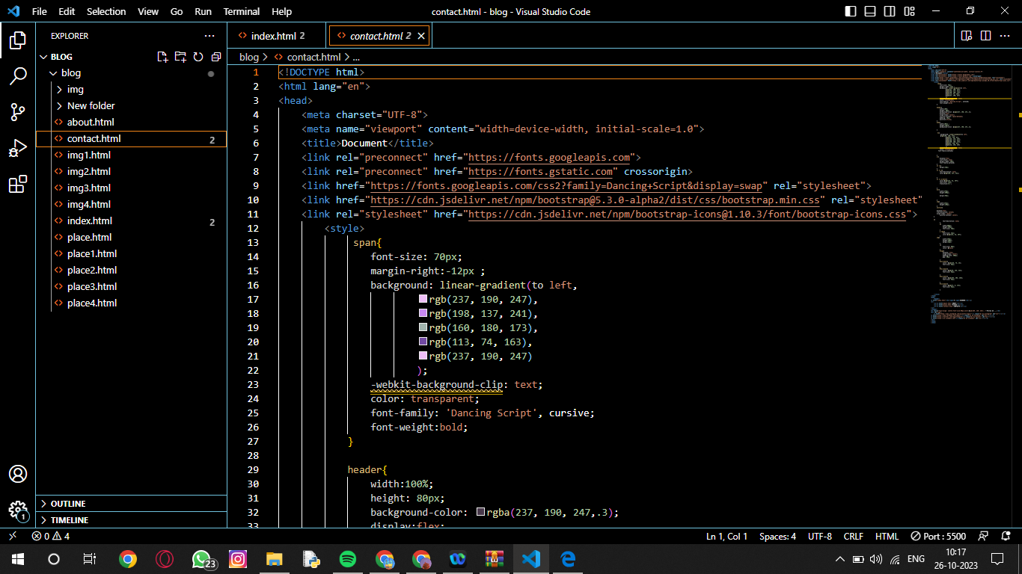

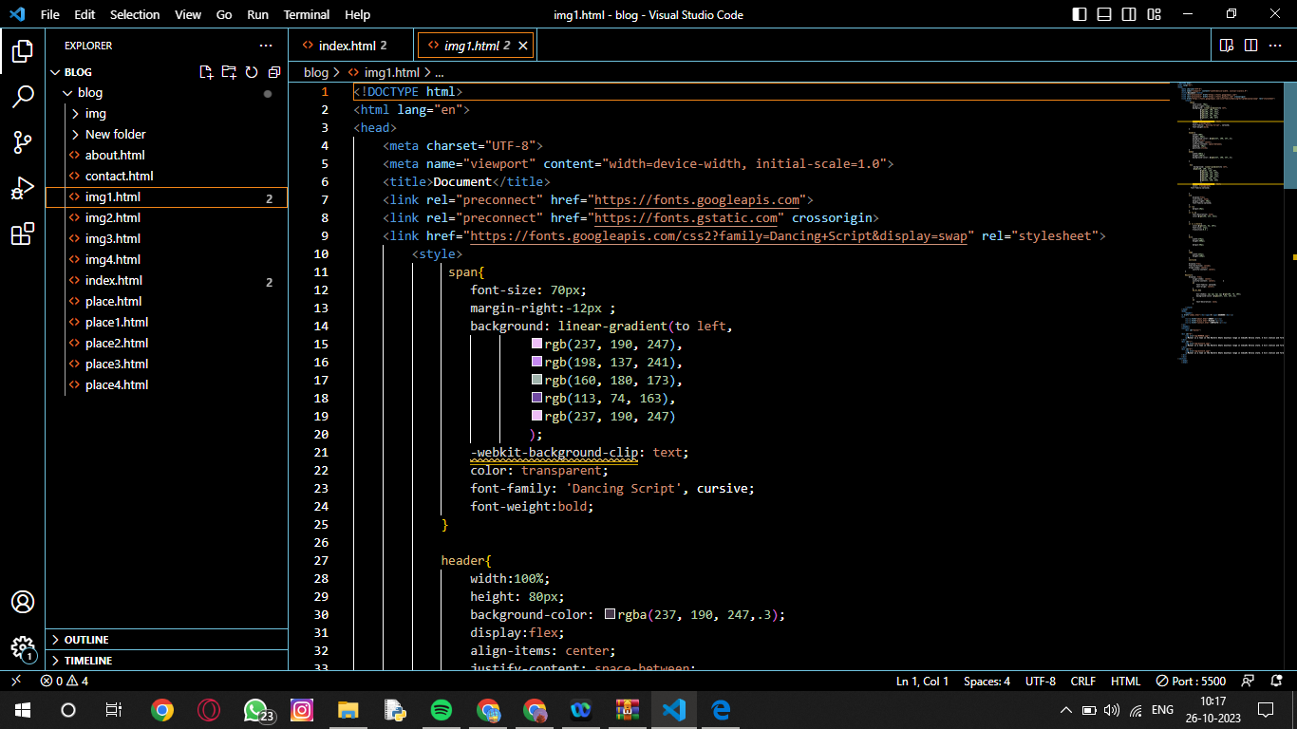

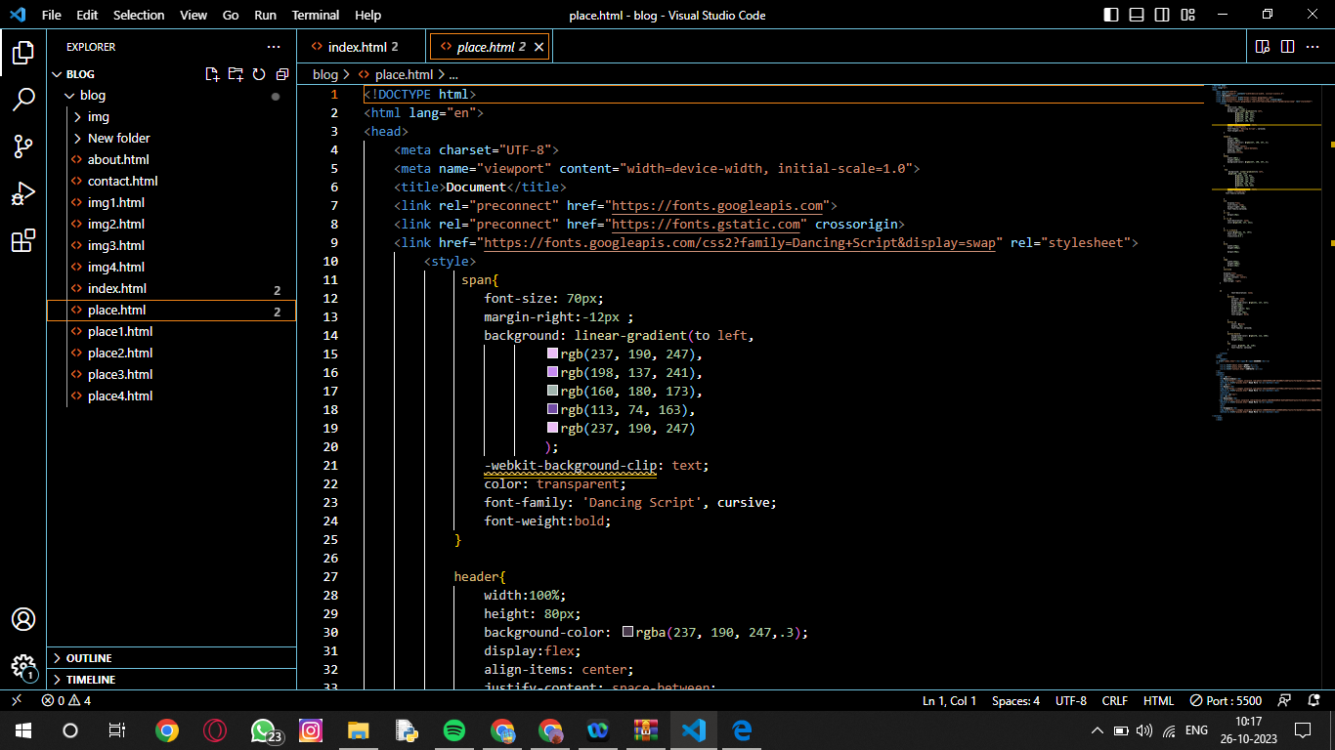

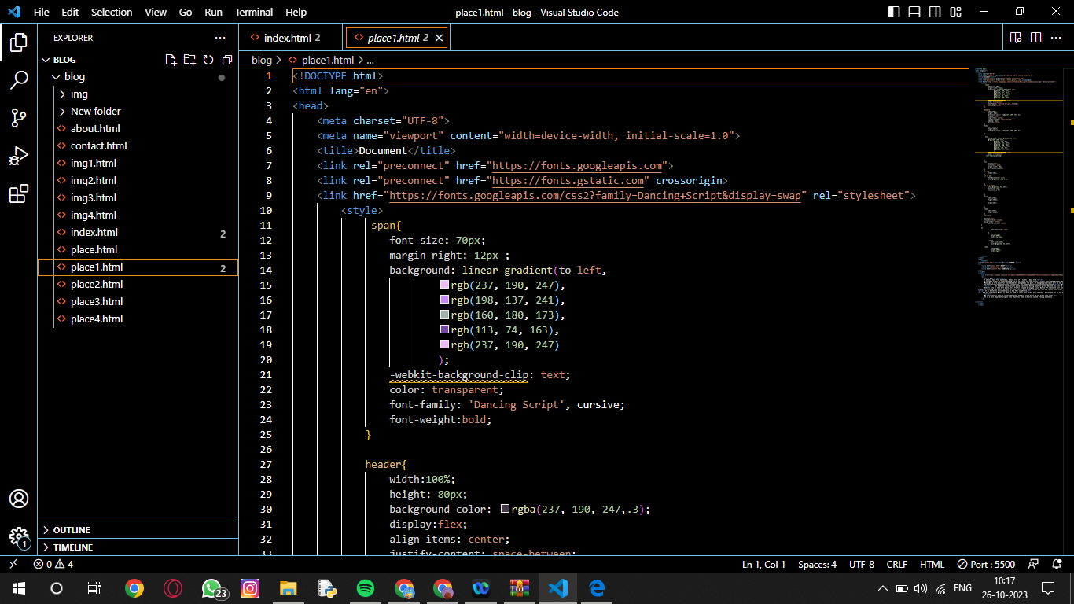

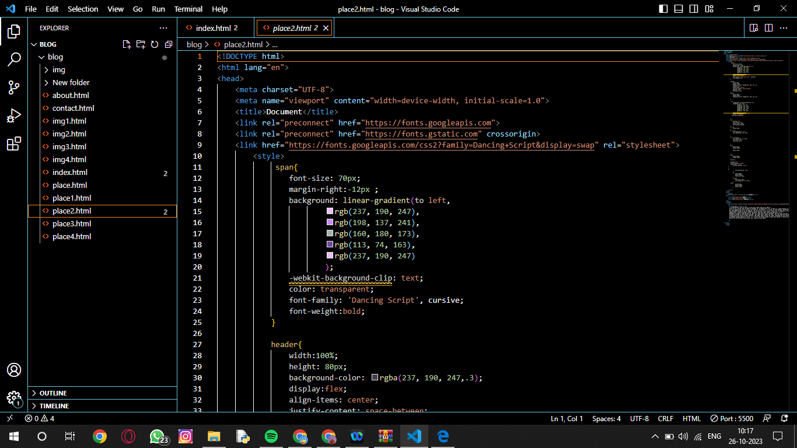

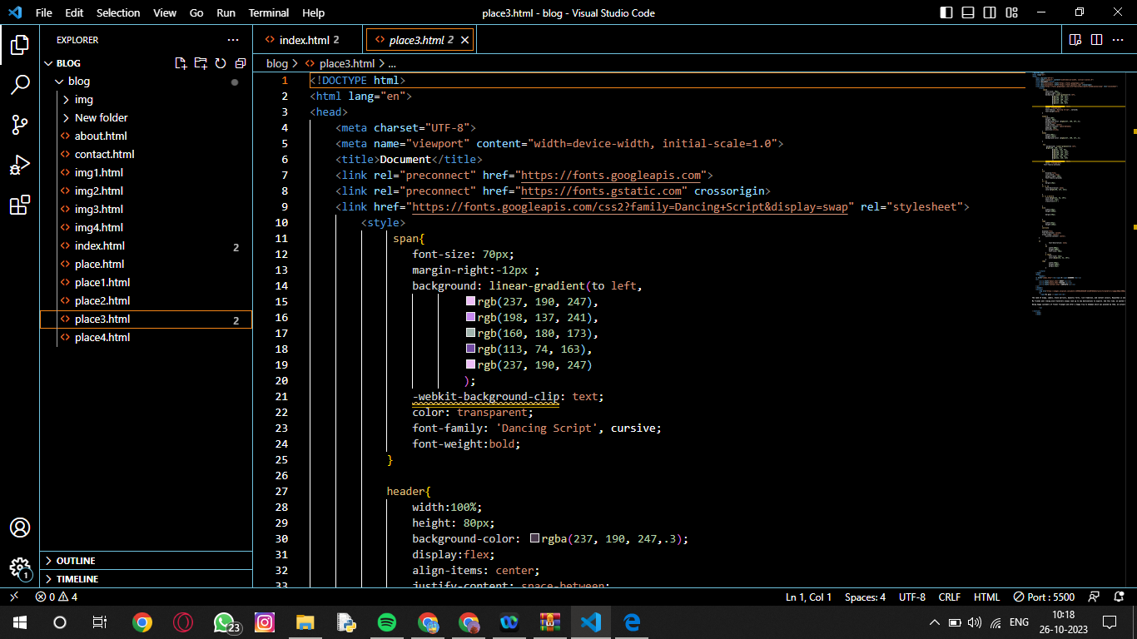

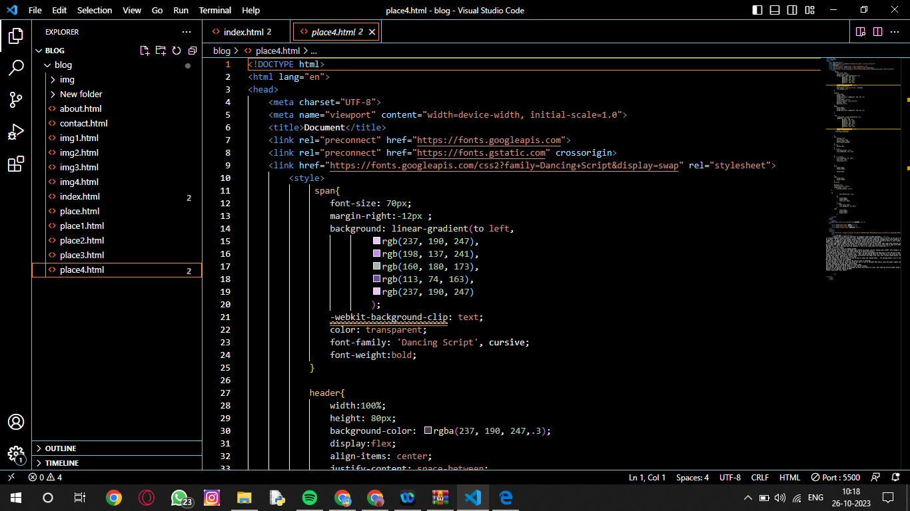

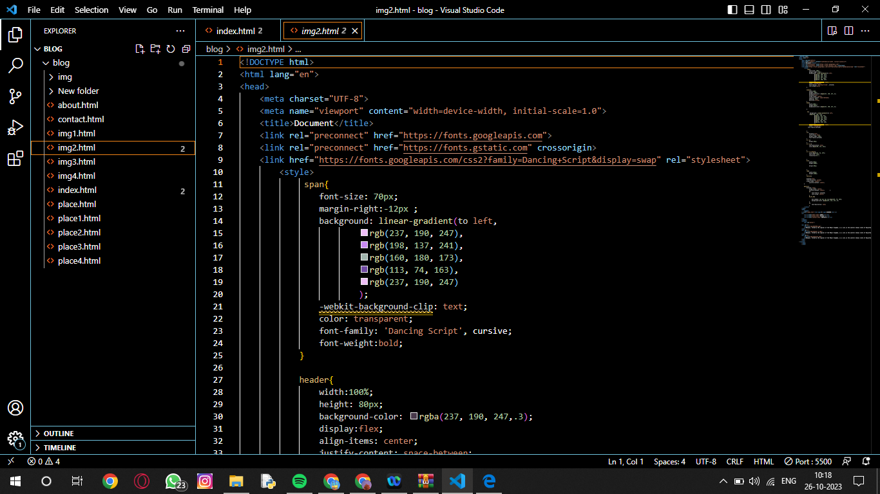

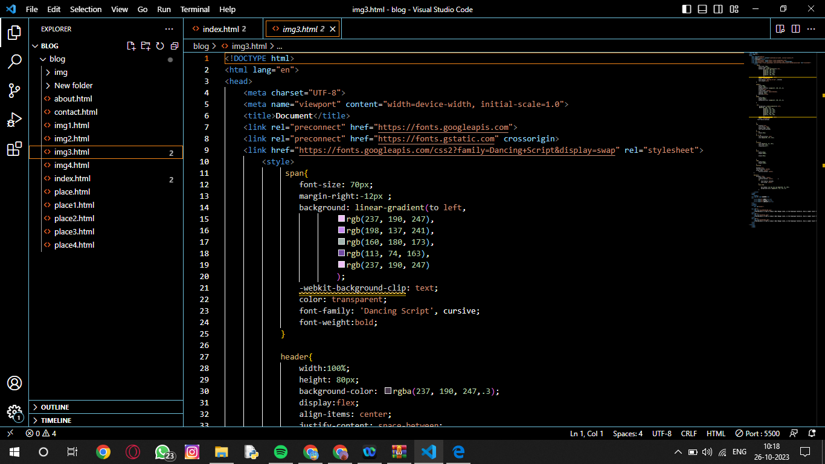

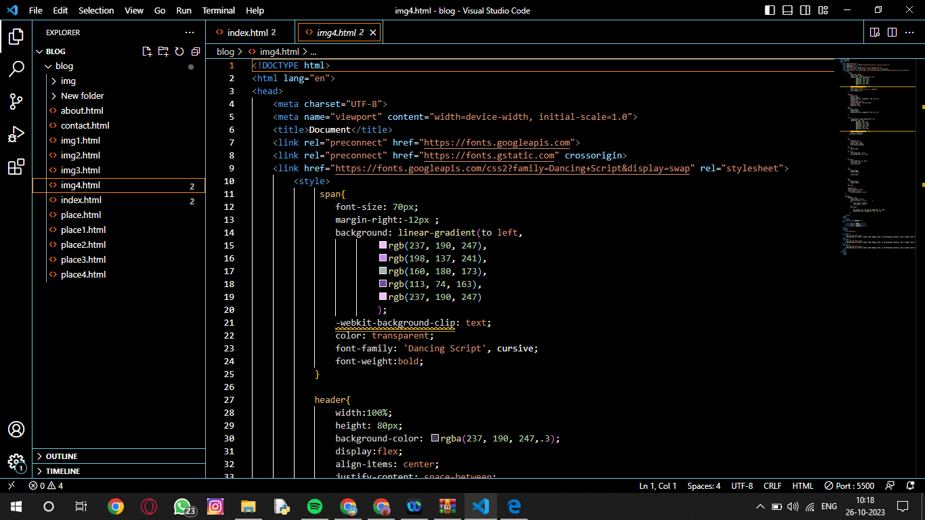

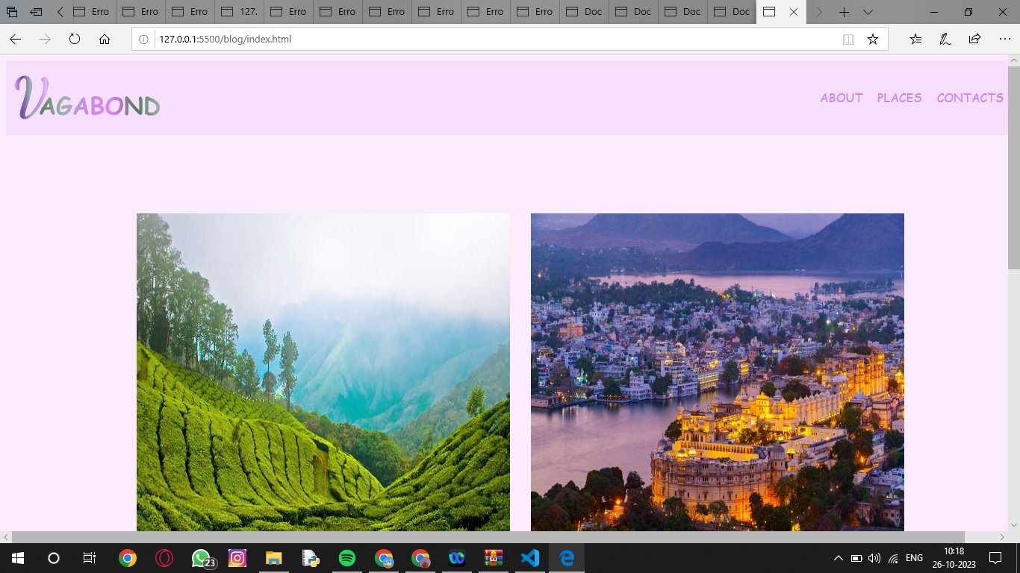

**-**

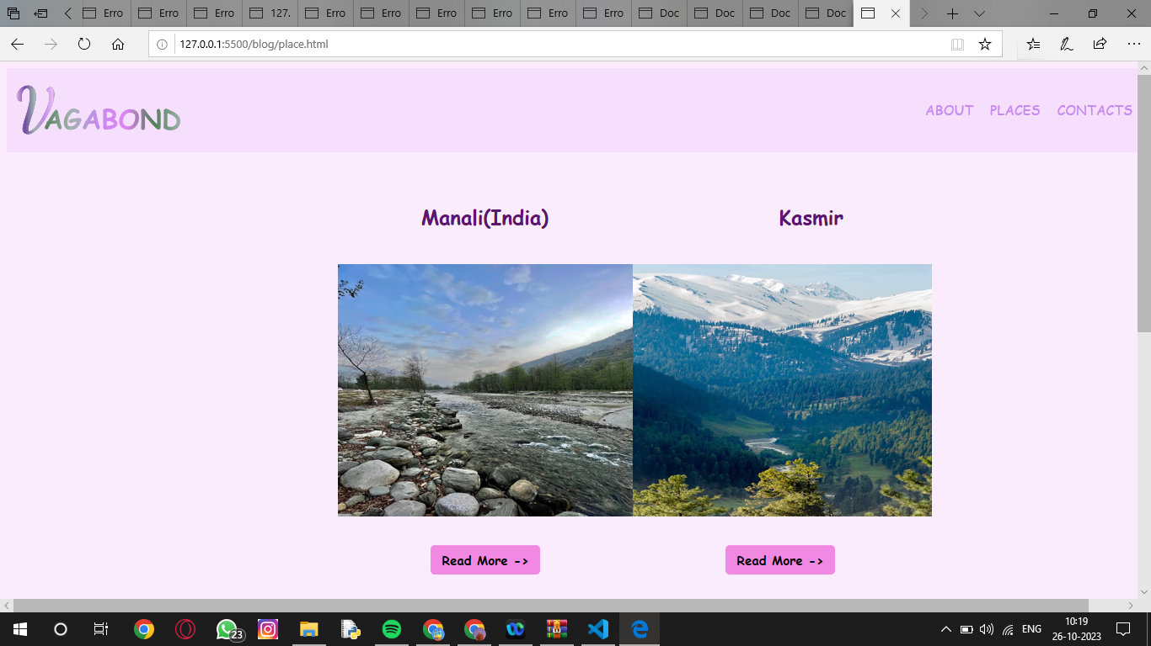

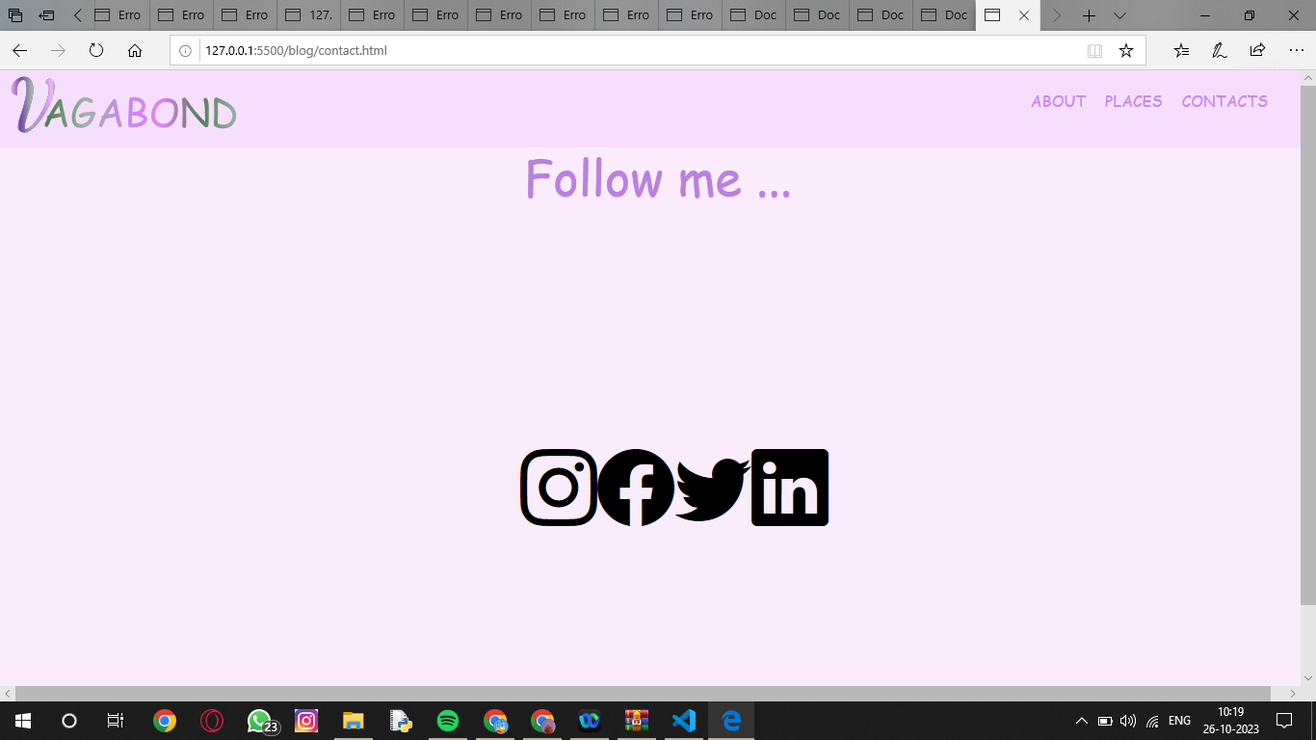

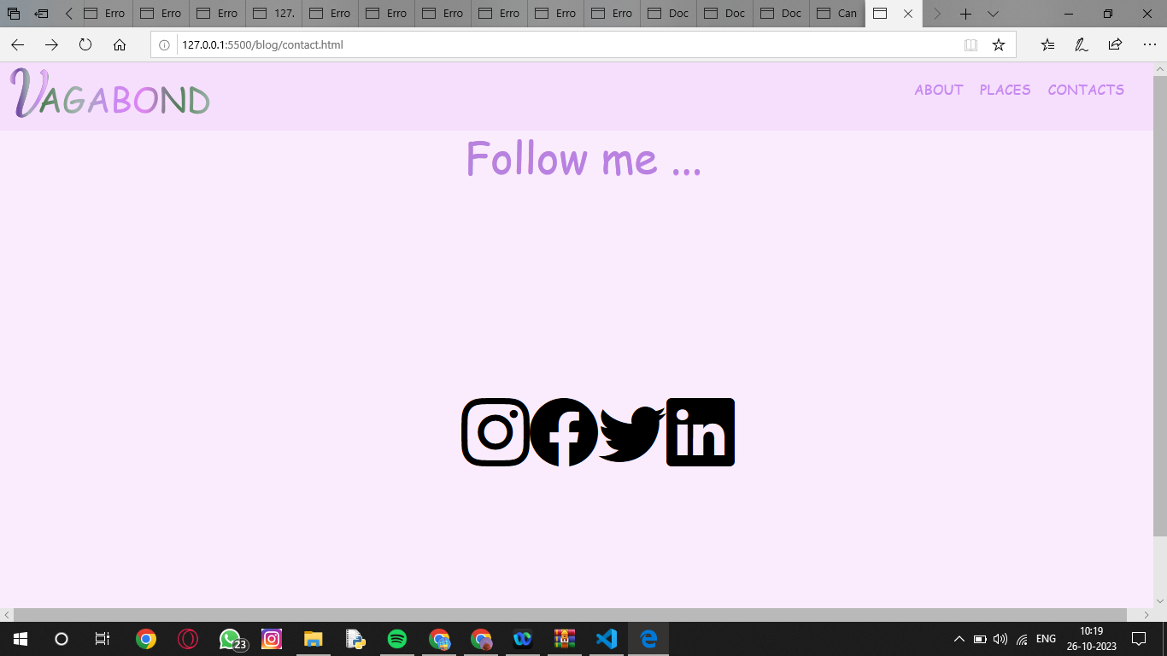

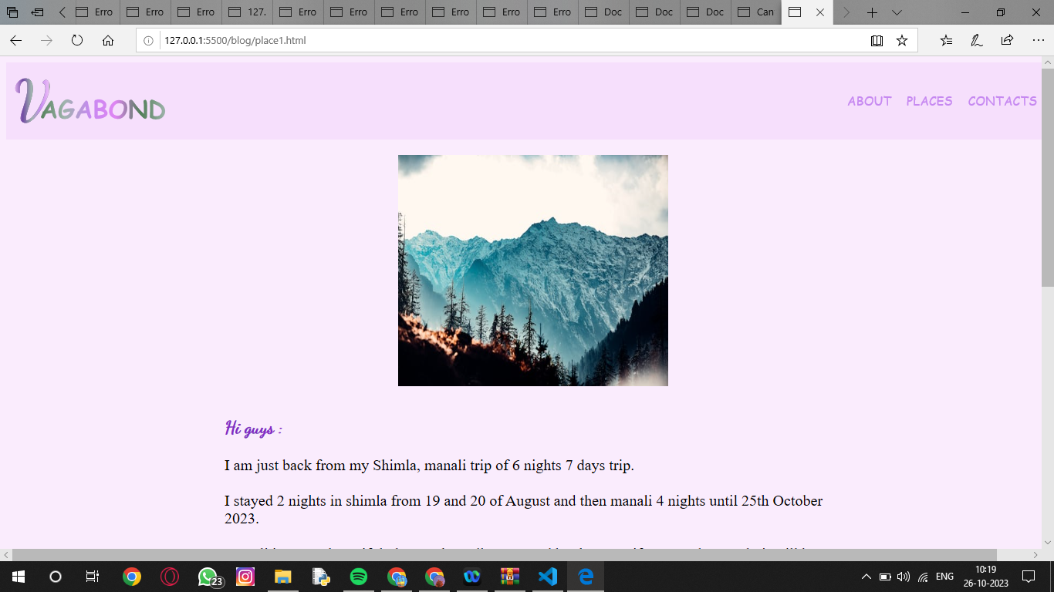

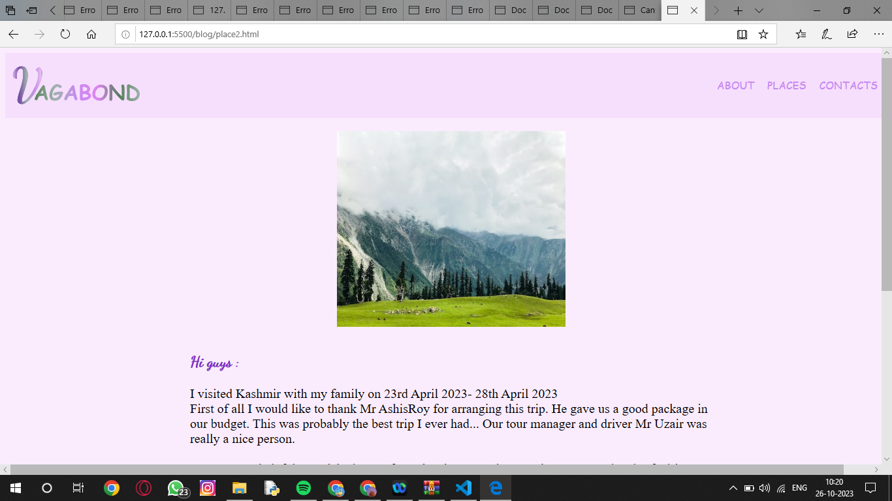

**CONCLUSION:**

We have implemented all the specific required tasks allotted to us. We have given the modular examples that we have created using HTML, CSS and JS.